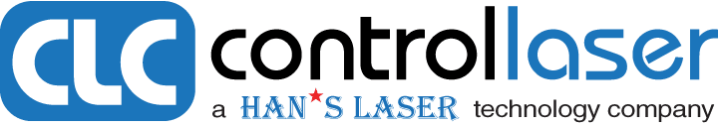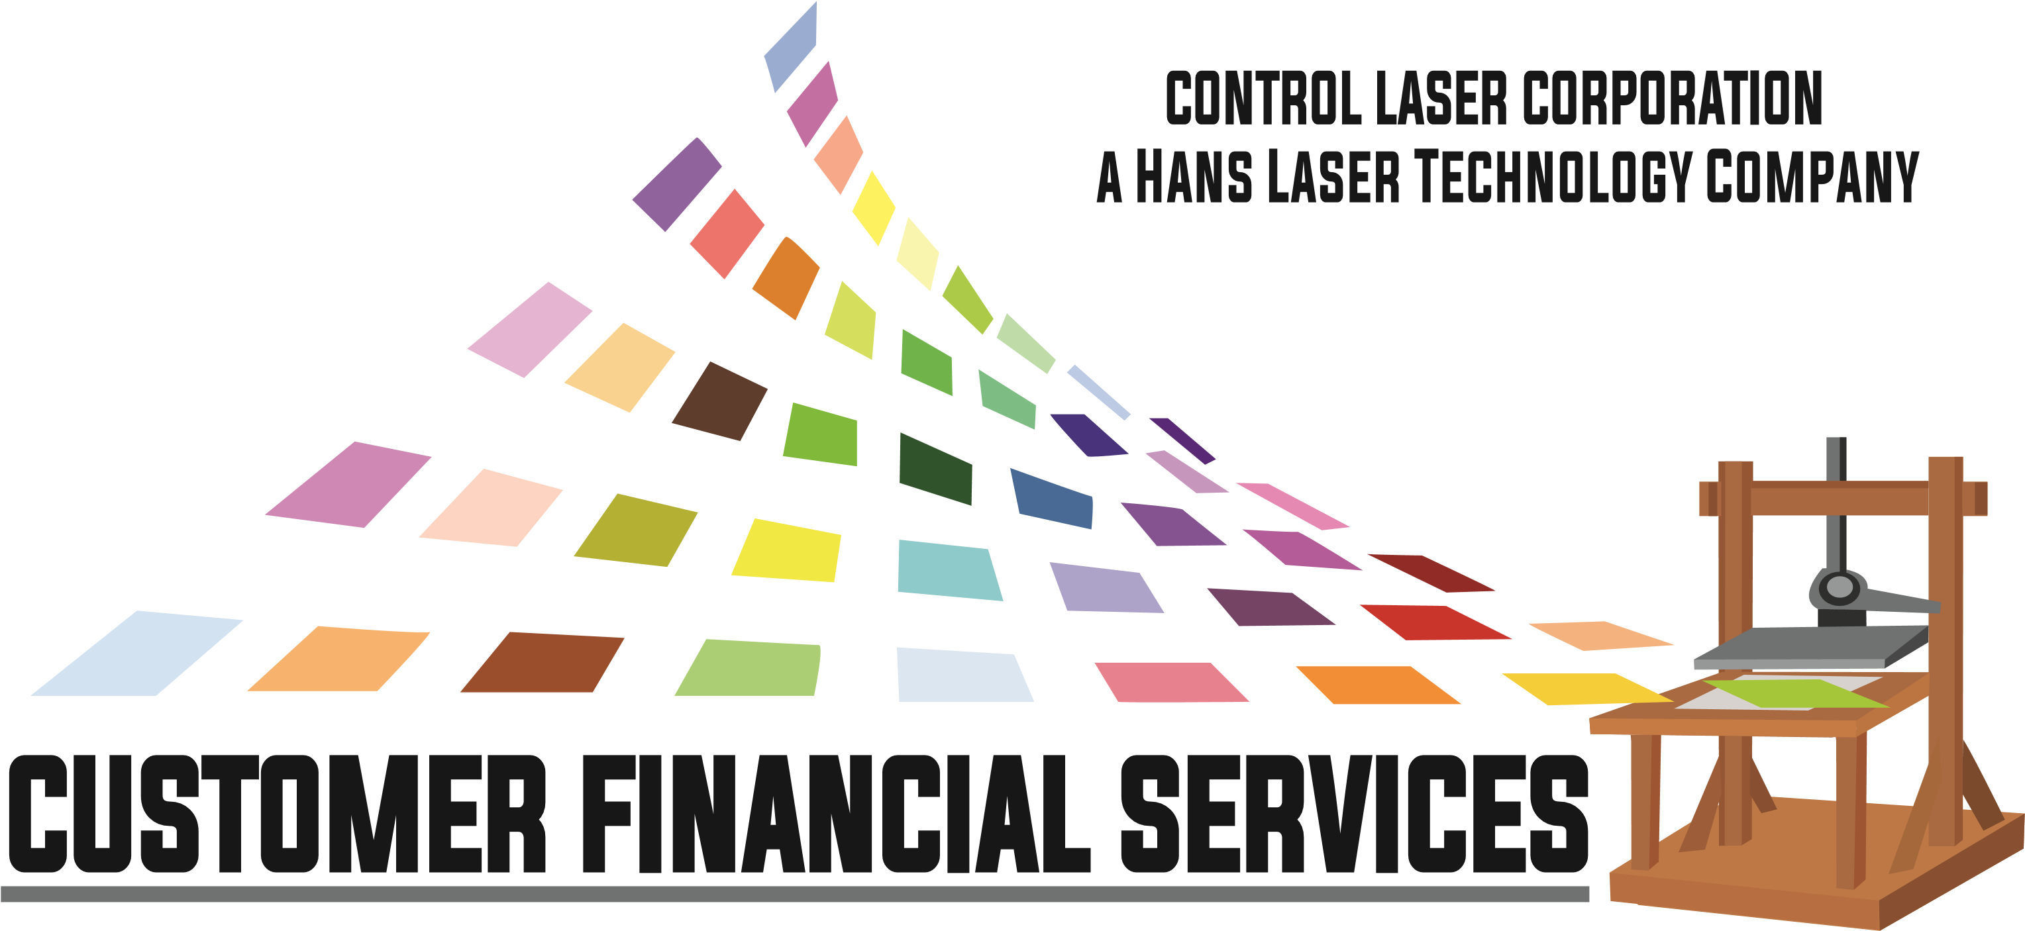
Customer Advantage Lease – Loan Application
Please send completed application A through E via e-mail to:
lou@customerfinancialservices.com. Office Assistance (910)253-7916

A. Customer Information .
Business Legal Name: | DBA Name (if any):
Street Address: | Federal Tax ID:
City/State/Zip Code: | Date Business Started: Number of Employees:
Phone: Fax: | E-Mail:

Corporation Limited Liability Company (LLC) Partnership Sole Proprietorship Other:

Annual Revenue Last 2 years $ $ Primary Product or Service:

B. Principal Information
Principal Name(s), Title(s): | 1. | 2. | 3.
Home address:
City / State / Zip Code:
% Ownership:
Social Security Number:
Signature: | x | x | x
Credit Release
Each individual signing as principal certifies that the information provided in this application is accurate and complete. Each individual signing as principal authorizes lender or any other lending sources to obtain information from the references listed below and obtain a consumer credit report that will be ongoing and relate not only to the evaluation and/or extension of the business credit requested, but also for purposes of reviewing the account, increasing the credit line, taking collection action on the account and for any other legitimate purpose associated with the account as needed. Each individual signing as principal further waives any right or claim which such individual would otherwise have under the Fair Credit Reporting Act in the absence of this continuing consent.
C. Bank Reference

Bank Name Checking Account # Phone # Contact Name:

D. Equipment Information
Equipment Cost: |  | Sales Rep Contact Name & Phone:
Equipment Description:

Finance Request: Loan____ or Lease____ | Term: Months | Lease Term Option: FMV____ $1.00 Out______ 10% Option______
ECOA Notice
The Federal Equal Credit Opportunity Act prohibits creditors from discriminating against credit applicants on the basis of race, color, religion, national origin, sex, marital status, age (provided the applicant has the capacity to enter into a binding contract), because all of or part of the applicants income is derived from any public assistance program, or because the applicant has in good faith exercised any right under the Consumer Credit Protection Act. The Federal Agency that administers compliance with this law is the Federal Trade Commission, ECOA Compliance, Washington, D.C. 20281.

Signature of applicant: X Date:
Customer Name: ________________________________________________
E. Current or Previous Loan and/or Lease Information
Bank or Lessor Name & Phone # | Date Opened | Account Number | Original Amount of Loan - Lease | Mo. Payment Amount | Remaining Months | Remaining Balance

Customer:
Thank you for your application with Customer Financial Services. It is a pleasure to say we are the financial services support group for our manufacturer, Control Laser Corporation, a Han’s Laser Technology Company and customers. Commercial laser equipment customer support and financing is our daily focus.

Our financial services customer support provides distinctive and effective leases and loans for the chosen equipment and is price competitive with the customer's credit profile. Due to the changing banking environment and current regulation constraints, customers may require alternatives for both cost efficient finance pricing as well as the additional credit structure accommodation and alternatives.

Your financial customer advantage is provided through nationwide distinctive and effective funds for your equipment acquisition with hands on support. Some of our relationship partners are Wells Fargo Equipment Finance, US Bancorp, Peoples Capital, Vision Financial, M-2 Leasing and select others. We are here to support your requirements and needs. To this end, your Advantage Financial Services provides:
- 100% Financing and an Alternative Source of Capital Equipment Funds.
- Available are lease and loan structures with terms of 3, 5 and up to 7 years on larger equipment.
3) Application Only lease terms (no financial statements or tax returns) up to $250,000 in equipment cost.
4) Customers receive highly competitive pricing commensurate with their credit profile.
5) Lenders are Preferred Bank & Finance organizations with underwriting that understands and supports our industry.
These are relationship funding partners that have committed to the extra steps for our customers.
6) You receive Direct Support through specialized and integrative laser financing knowledge with over 30 years of hands on experience.

Our contact information is:
Louis (Lou) Panigutti, Director
CLC Customer Financial Services
2632 St James Dr SE Ste 200
Southport, NC 28461
910/253-7916 Office
910/274-3681 Cell
email lou@customerfinancialservices.com

Please complete this application and return it for an expedited processing.

We look forward to helping you acquire a supportive loan or lease for the equipment you have selected. If we can be of further assistance, please do not hesitate to let myself or your equipment representative know.

Respectfully,
Lou Panigutti

